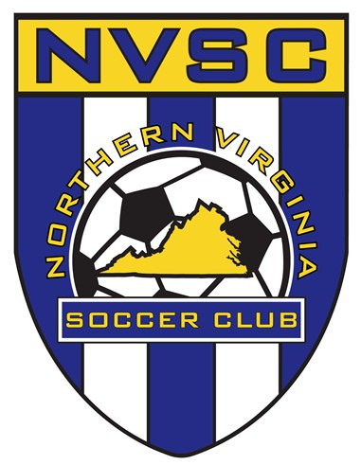
NVSC UNITED SMART Goals

Name: _____________________________________
Team Name:__________________________________
Uniform Number: _____________

Setting Goals- Identifying something that you want to accomplish
Ex. By the end of the season I want to be able to use two different moves to beat players 1 vs. 1.
Specific
Measurable
Attainable
Relevant
Timely
Things to remember
- Be realistic, set small goals to start with, you can move to the bigger stuff when you get better at setting and reaching goals.
- Keep feeling positive. Don't let other people put you off.
- Check your time line every day and read through your goal again.
- Believe you can do it.
- Keep adding more small steps if it doesn't look like you're making a lot of progress.
6Tell someone you trust about what you are doing. Talking about it will keep you feeling good and help you to work out your steps, what to learn and who can help.
My Three Goals For The Fall Season Are:

- ____________________________________________________

____________________________________________________

- ____________________________________________________

____________________________________________________

- ____________________________________________________

____________________________________________________

